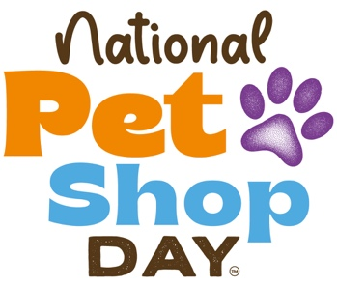
[Your Pet Shop Name]
[Your Address]
[City, Postcode]
[Email Address]
[Phone Number]
[Date]
[Recipient’s Name]
[Business Name]
[Business Address]
[City, Postcode]

Dear [Recipient’s Name],
RE: STRENGTHENING OUR LOCAL COMMUNITY – JOIN US FOR NATIONAL PET SHOP DAY!
I hope this letter finds you well. I’m reaching out because as fellow local businesses, we share a common goal - creating a thriving, connected community. That’s why we’d love for [Business Name] to join us in celebrating National Pet Shop Day on Saturday, 12th July 2025 - a day dedicated to highlighting the importance of shopping local and supporting high street businesses like ours.
Why supporting local matters
Local businesses are the backbone of our community, providing not just products and services but also personalised customer care and a sense of belonging. As a pet shop, we are proud of the unique position we have as a trusted health and wellbeing hub for pet owners, providing invaluable face-to-face support and expert advice to animal lovers.
However, independent retailers, including pet shops, face increasing challenges in today’s economic climate. Government statistics from 2023 showed that over 10,000 UK high street stores closed in just one year. If we want to keep our high streets vibrant, we must work together.
By supporting one another, we create a stronger, more resilient local economy - one that benefits us all. When customers visit a pet shop, a café, or another business on their high street, they’re not just making a purchase; they’re investing in their community. The success of one local business can have a ripple effect on others, driving foot traffic, increasing visibility, and fostering loyalty.
How we can support each other
We’d love to collaborate with [Business Name] to make National Pet Shop Day a success - not just for us, but for the wider community. Here are a few ways you can get involved:
- Cross-promotion: Share the event on your social media channels, website, or in-store to encourage your customers to participate.
- Special offers or discounts: Consider offering a small promotion for pet owners who visit both our businesses on the day.
- Prize giveaways: If you’re able, contributing a small prize for a competition could be a great way to engage more customers.
- Community event participation: Let’s join forces to create a celebration that brings people together!
Let’s work together!
We believe that by supporting each other, we can make a real impact, not just to our store but to the wider high street. We’d love to discuss how we can collaborate to make National Pet Shop Day an event that benefits all of us. Please let us know if you’d be interested in participating as we’d be delighted to explore opportunities with you!
Thank you for your time and consideration. Together, we can strengthen our local community and keep our high streets alive!
Best regards,
[Your Name]
[Your Position]
[Your Pet Shop Name]
[Your Contact Information]
For more details, visit www.nationalpetshopday.co.uk.

